Abstract— This paper develops a contrast enhancement technique to recover an image within a given area, from a blurred and darkness specimen, and improve visual quality. In this paper, Image enhancement is performed using soft computing tools (e.g., genetic algorithm, fuzzy logic) and Image ambiguity optimization. Genetic Algorithms (GAs) are used to find the optimum parameter set for computing the functions used for image enhancement. Fuzzy Logic is used to take a decision about the quality of the enhanced image by associating values with them. Here grayness ambiguity (Entropy: DeLuca and Termini) is taken into consideration. Gray level ambiguity measures take care of global information.
Fuzzy Image Ambiguity Optimization for Image Enhancement using Genetic Algorithm
Amiya Halder, Anindita Ghosh, Sarani Bhattacharya and Ankita Saha

Keywords—Image Enhancement, Genetic algorithm, Fuzzy Logic, Entropy, Image Ambiguity, Gray level Ambiguity.

INTRODUCTION
Image enhancement is used to improve the quality of an image for visual perception of human beings. The main techniques for image enhancement such as contrast stretching, slicing, histogram equalization etc, for grey scale images are discussed in many books, these transformations are linear. For image enhancement, one needs to improve the visual quality of an image without distorting it. Several algorithms are available for contrast enhancement in grey scale images, which change the grey values of pixels depending on the criteria for enhancement.
Contrast enhancement is one of the most important problems in image processing both digital and analog. In several cases the image acquired in severe conditions are too dark and blur and therefore difficult to recognize the different objects or scenery contained in the image. Therefore, image enhancement algorithms are applied to improve the appearance of an image for human visual analysis or occasionally for subsequent machine analysis [1]. The image enhancement methodology dependents on the application context; criteria for enhancement are often subjective or too complex to be easily converted to useful tools. However, it is well known that a global image enhancement method for all classes of imagery is missing.
Classical techniques [2], [3] for digital image contrast enhancement are usually based on the analysis of the histogram, and known as point-operation global methods. In the global histogram equalization-based methods, various constraints are added to the equalization procedure to achieve better performance. The global techniques completely fail when the original image is already occupying the full dynamic range, or when the contrast is varying in different parts of the image. Linear stretching of the brightness in monochrome images [4] are the standard methods to cover the available dynamic-range. Nonlinear functions like the exponential and logarithmic can also be used to preferentially stretch the contrast in bright and dark regions respectively. Adaptive histogram equalization techniques [5], [6] use statistical information in the neighborhood of each pixel to perform equalization. The major problem with adaptive histogram equalization methods is the over-enhancement effect, creating objects that were not visible in the original image. The enhanced image often does not look natural and is disturbing [7], [8], [9]. A multi-scale algorithm has been proposed in [10] to enhance the visibility of local features in an image, based on a gamma-like correction and multi-scale decomposition.
In this paper, we propose a contrast enhancement algorithm in both brightness and spatial domain. The basic idea of this approach is to enhance fully-automatically the optical quality of low contrast images. This is achieved by using nonlinear transformation-based mapping function, genetic algorithm and gray level ambiguity (i.e. entropy function). When the global contrast of an image is degraded, the contrast enhancement is achieved using a suitable transformation function. The proposed algorithm performs global transformation of the original image, increasing the contrast only in the low-quality regions.
The structure of the paper is as follows: in the next section the proposed method is described in detail. The experimental results applying on real images are presented and discussed in section 3. Finally, the paper is concluded with directions for further algorithm improvement.
.

NONLINEAR TRANSFORMATION FOR CONTRAST ENHANCEMENT
Contrast stretching, slicing, histogram equalization and some other enhancements are necessary for a specific application, more specifically, to improve the visual judgment of the picture. But all the above techniques for image enhancement are problem dependent. Basically, each linear and nonlinear functions work in different ways and their effectiveness are very much problem dependent or image dependent.
Therefore, the questions that naturally arise are ‘Given an arbitrary image, which type of functional form will be best suited without the prior knowledge of image statistics for highlighting its objects?’ And also ‘knowing the enhancement function, how one can quantify the enhancement quality for obtaining the optimal one?’ The answer of the above questions are very much problem dependent. Regarding the first question, even if we are given the image statistics it is possible only estimate, approximately, the function required for the enhancement and the selection of exact functional form still needs human interaction in an iterative process. The second question, on the other hand, needs individual judgment, which makes the optimal decision subjective. So, selecting an appropriate transformation function for an image is very difficult.
In this proposed method, we used four nonlinear transformation functions for image enhancement. The mathematical forms of the functions are given below [5].

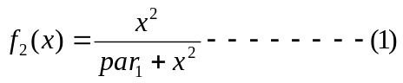
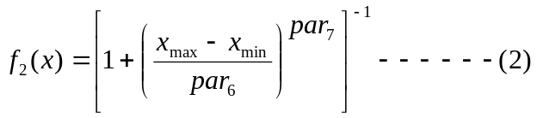
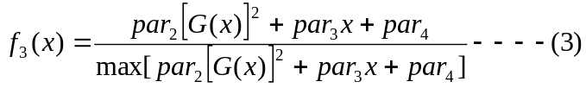

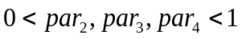

Where
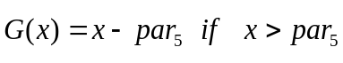
= 0 otherwise,

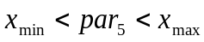

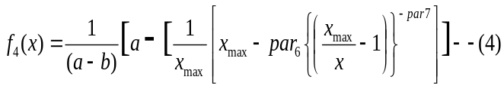
Where

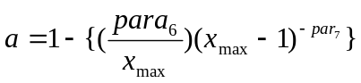 and
b= 0.5 to 0.9.

Here, gray_{min} and gray_{max} are the minimum and maximum value of the gray level range for an image.
Parameters Range
par₁-par₄  par₅ & par₆  par₇ | [0, 1]  (gray_{min} , gray_{max})  [1 , 3]

GENETIC ALGORITHM

Genetic algorithms are adaptive and robust computational procedure modeled on the mechanics of natural genetic systems. GAs act as a biological metaphor and try to emulate some of the process observed in natural evaluation. They are viewed as randomized search and optimization techniques. They express their ability by efficiently exploiting the historical information to speculate on new offspring with expected improved performance. GAs is executed iteratively on a set of coded solutions, called population, with three basic operators: selection/reproduction, crossover and mutation [4, 7]. Genetic algorithms generate a sequence of population by using a selection mechanism, and use crossover and mutation as search mechanism.

Simple GA

Essential to the SGA’s working is a population of binary strings. Each string of 0s and 1s is the encoded version of a solution to the optimization problem. Using genetic operators, crossover and mutation, the algorithm creates the subsequent generation from the strings of the current population. This generational cycle is repeated until a desired termination criterion is reached (e.g., a predefined number of generations are processed or a predefined optimized value is being reached). (Fig. 3.1) summarizes the working of SGA [6].

Simple Genetic Algorithm ( )
{
initialize population;
evaluate population;
while termination criterion not reached
{
select solutions for next population;
perform crossover and mutation;
evaluate population;
}
}

Basic component of a GA
The main components of SGA are given bellow.

1. population of binary strings
2. fitness function.
3. selection mechanism
4. genetic operators
5. mechanism to encode the solutions as binary strings.

Let us briefly describe the components:
Population- To solve an optimization problem, GA starts with the chromosome (structural) representation of a parameter set {x1, x2, x3…xp}. The parameter set is to be coded as a finite length string over an alphabet of finite length. Usually, the chromosomes are strings of 0’s and 1’s. For example, let {a1, a2, a3…ap) be a realization of the parameter set and the binary representation of a1, a2, a3…ap be 10100, 10010, 11111…11001, respectively. Then the string 101001001011111…11001 is a chromosome representation of the parameter set {a1, a2, a3… ap}. Each chromosome actually refers to a coded solution. A set of such chromosomes in a generation is called a population. The size of the population may vary from one generation to another or it can be kept constant. The initial population is chosen randomly [4].
Fitness function- The objective function, the function to be optimized, provides the mechanism for evaluating each string. It is chosen in a way such that highly fitted strings have high fitness values. It is the only index to select the chromosomes to reproduce for the next generation [6].
Selection Mechanism- Selection mechanism models nature’s survival-of the fittest mechanism. Fittest solutions survive while weaker ones perish. Selection procedure copies individual strings (called, parent chromosome) into a tentative new population (known as mating pool) for genetic operations. Roulette wheel parent selection and linear normalization selection are the most frequently used selection procedures.
In the Roulette wheel selection scheme, each string is allocated a sector of a roulette wheel with the angle subtended by the sector at the center of the wheel equal to 2Π fi/f, where fi is the fitness value of the ith string and f is the average fitness value of the population [6].
Genetic Operators- Genetic operators are applied on parent chromosome and new chromosomes are generated. Frequently used genetic operators are discussed below.
- Crossover- The main purpose of crossover is to exchange information between randomly selected parent chromosomes with the aim of not losing any important information. Here in the first step, pairs of strings (known as mating pair) are picked at random by selection procedure from the population. The second step determines, on the basis of the crossover probability, whether this pair of chromosome should go for crossover or not. Interchange of chromosome segments between mating pairs is done in the last step. Some commonly used crossover techniques are one point crossover, two point crossovers and multi point crossover [4]. We illustrate here one point crossover. In this crossover technique position k is selected at random between 1 and l-1, where l is the string length. Two new strings are created by swapping all characters from position (k+1) to l.
Let:
a=110001010101000…0111110001
b=100010111011101…0011010100
be two parent strings selected for the crossover operation and the random number generated be 11(eleven). Then new produced offspring will be
a’=110001010101101…0011010100
b’=100010111011000…0111110001
- Mutation- After crossover, strings are subjected to do mutation. Mutation of a bit involves flipping it: changing from 0 to1 or vice versa. Just as crossover probability controls the crossover, here in mutation another control parameter, mutation probability controls mutation. A random number position of a random string is being selected and mutation flips that bit [6, 8]. Let
a= 110001010101000…0111110001
be a string to perform mutation and 3rd bit of the string is selected for mutation. Then the transformed string after mutation will be
111001010101000…0111110001
The main aim of mutation is to introduce genetic diversity into the population. Sometimes it helps to regain the information lost in earlier generations.

Genetic Algorithm for Image Enhancement
All these above functions discuss in section II perform contrast enhancement of an image. We have used the parameters par1 to par8 to get family of curves, so that according to the quality of the enhancement desired, these parameters can be defined in section V.
For investigation we use the convex combination of these functions, i.e.
f(x) = par9 f1(x) +par10 f2(x) + par11 f3(x) + par12 f4(x)………(3.1)
such that par9 + par10 + par11+par12= 1
where 0 ≤ pari ≤1, where i=9,10,11,12.
Hence we get 12 parameters all total, and their combination will enable one to stretch or compress any region of an image according to his /her desire. As a result, we have to determine an optimum set of values of these 11 parameters in order to achieve a desired enhancement, and GA is used to determine these values automatically.
Let us consider the problem of enhancement by gray level rescaling. In gray level rescaling, each pixel is directly quantized to a new gray level in order to improve the contrast of an image. The simplest form of the functional mapping may be expressed as
x’mn=xmax f (xmn),
where, xmn=gray value of the (m, n)th pixel in the input image, x’mn=transformed enhanced value of the (m, n)th pixel, f(x) is defined as the convex combination of the four transformation functions mentioned above, xmax is the maximum value of the gray level dynamic range [5].
In the following sections we will describe the way of formulating the components of GA, in the context of automatic image enhancement problem.

Representation of Parameters
Let the 12 parameters which we have introduced in the section II and III, be denoted as par1, par2, par3,…,par12 and these parameters have different domains as described earlier in section II and III.
For implementation of GA for automatic image enhancement, we use 10 bit binary string for each parameter. So, we have altogether 120 bits binary string for 11 parameters as shown bellow.
1110110101 1101011010 0110101010…1101010010 3.2.3(a)
par1 par2 par3 par12
To evaluate the fitness function we have to decode the binary string for each parameter into its proper decimal equivalent.
Now if we want to decode par1 and par2 for example, then we have to pick the first (1110110101) and second (1101011010) substrings of bit length 10 from the 120 bit length string. So the 10 bit string representations for par1 and par2 are respectively 1110110101 and 1101011010.
Since, they are all 10 bit string, so the decimal equivalents of these two strings are less than 210-1.
We get d1=949 and d2=858 as their decimal equivalent. Since the ranges for par1, par2 are different from the ranges of the decimal equivalent thus obtained. So we have to map these equivalent decimal numbers d1 and d2 into their proper ranges, i.e. the ranges of par1 and par2 respectively.
Let the range of pari be [pari, min, pari, max] where i=1, 2…11 and the range of their decimal equivalent be [di, min , di, max ]. Then to map di into the range [pari, min, pari, max] we use the following formula,
di = {(pari, max - pari, min) * vi/(210 -1)}+ pari, min
Using this formula we get the proper decimal equivalent for par1 and par2 where d1=0.927663734 and d2=0.838709677. In general to find the proper decimal equivalent for pari, we first choose the ith substring of bit length 10 from left. Then decode and map them as described earlier.

Evaluation Function
We need an evaluation function for quantifying the desired enhancement; i.e. to objective the subjective evaluation. This evaluation function reflects the fitness function of GA. Here we have used Image Ambiguity i.e gray level ambiguity the quantitative indices for picture quality.

Image Ambiguity
A gray tone image possesses ambiguity within each pixel because of the possible muli-valued levels of brightness. If the gray levels are scaled to lie in the range [0,1], we can regard the gray level of a pixel as its degree of membership in the set of high-valued ‘bright’ pixel; thus gray tone image can be viewed as a fuzzy image subset. Regions, features, primitives, properties, and relations among them, which are not crispy defined, can similarly, be be regarded as fuzzy subsets of images[7].

A L level image A ( of size MxN) can be considered as an array of fuzzy singletons, each having a value of membership denoting its degree of processing some property (e.g brightness, darkness, texture etc.). In the notation of fuzy sets one may , therefore, use the following :
A={µA(xmn):m=1,2..M; n=1,2,..N},
where µA(xmn) denotes the grade of processing such a property µ by the (m,n)th pixel. Grayness ambiguity means indefiniteness in deciding whether pixel is object or background and considers only global information.

Graylevel Ambiguity

Entropy: The entropy of a fuzzy set image can be defined by various methods of which we have used Deluca &Termini. Entropy of a fuzzy image subset is a logarithmic gain function given by
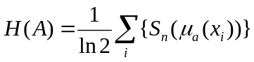 With
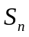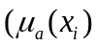=-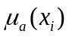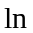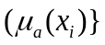

Proposed Algorithm
The proposed algorithm for automatic image enhancement using GA is given below. The input is an image X.

Algorithm:

Step1: Create initial population (strings of 0’s and
1’s) for parameter set Q1j
Step2: Decode parameter strings Pij into their respective
Domains
Step3: Transform X using Pij
Step4: Compute fitness value Fij
Step5: If (j NOT EQUAL TO N)
THEN
Change parameter set, GO TO Step 3
ELSE
Sort Ii j
Step6: IF (i= No. Gen)
THEN
{
6.1.1 Select PNo.Gen, 1 as optimal parameter set
6.1.2 Enhance X using PNo. Gen, 1
6.1.3 Output enhanced image
}
ELSE
{
6.2.1 Create Mating pool with Qi j
6.2.2 Select (randomly) two strings
6.2.3 Perform Cross-over
6.2.4 Perform Mutation
6.2.5 IF (population size EQUAL TO N)
THEN
GO TO Step 2
ELSE
GO TO Step 6.2.2
}
STOP.

In the above mentioned algorithm Qij, Pij, and Iij represent the strings of 0 and 1, their decoded version and the fitness values respectively, corresponding to jth parameter set of ith generation; N is the population size and No. Gen is the number of generations to be executed.

EXPERINTAL RESULTS
The proposed algorithm has been applied to well known natural images such as Lena, mandrill and peppers. All the results have been reported in Table I.
The assumptions used for the implementation of the proposed algorithm are given as follows. The value of the parameter, c, for the validity index referred to from [8], is set to 25. The size of the population, P, is taken as 30, crossover rate, μc, as 0.9 and mutation rate, μm, as 0.01[6]. The algorithm uses number of iterations as the terminating condition and it is set to 20. The value of Kmax is empirically set for the individual images. The maximum intensity level for each picture element in the image is taken as 255.

Figure 1: (a),(d),(g),(j)-Original Image
(b),(e),(h),(k)-Image by histogram equalization
(c),(f),(i),(l)-Output Image by proposed method

CONCLUSIONS
Dark and blurred images are very common outputs vast range of imaging application e.g. medical imaging , GIS, low light photography etc . We have proposed a new algorithm for enhancing the visual quality of such images without distorting the contrast balance and introducing artefacts which is simple to implement on a wide variety of images.
References
- J.R. Jenson, “Introductory digital image processing ”, Prentice Hall 2005
- Jain, A.k., 1989, “Fundamentals of digital image processing, Prentice-Hall, Eglewood Cliffs NJ
- Rosenfeld, A., and Kalk, A. C., 1982, “Digital Picture Processing”, Prentice Hall, Academic Press, San Diego
- J.DiCarlo and B. Wandell, “Rendering high dynamic range images,” in Proc. SPIE Electronic Imaging, vol. 3965, (San Jose,CA), pp. 392–401, 2000.
- [5] Pfizer S.M. et al, “Adaptive Histogram Equalization and its Variations”, Computer Vision, Graphics and Image Processing, vol. 39, pp. 355-368, 1987.
- J.A. Stark and W.J. Fitzgerald, “An Alternative Algorithm for Adaptive Histogram Equalization”, Graphical Models and Image Processing,, vol.56, pp.180-185, 1996.
- J. A. Stark, “Adaptive image contrast enhancement using generalizations of histogram equalization,” IEEE Transactions on Image Processing, vol. 9, no. 5, pp. 889–896, 2000.
- F.P.P. De Vries “Automatic, adaptive, brightness independent contrast enhancement”, Signal Processing vol. 21, pp. 169-182, 1990
- J. L. Starck, F. Murtagh, E. Candes, and D. L. Donoho, “Gray and color image contrast enhancement by the curvelet transform,” IEEE Trans. Im. Proc., vol. 12, pp. 706–717, 2003.
- Rafael C. Gonzalez, and Richard E. Woods, Digital Image Processing. Pearson Education Asia, Sixth Indian Reprint, 2001.
- Malay K. Kundu and Sankar K. Pal, “Automatic Selection of Object Enhancement Operator with Quantitative Justification Based on Fuzzy Set
Theoretic Measure, “Pattern Recognition Letters, vol. 11, pp. 811-829, 1990.
- Susmita De, Ashish Ghosh and Sankar K. Pal, “Fitness Evaluation in Genetic Algorithms with Ancestors’ Influence,” Genetic Algorithms for Pattern Recognition, Sankar K. Pal and P.P.Wang(eds.) ,CRC Press, Boca Raton, USA, pp. 1-23, 1996.
- Sankar K. Pal, Dinabandhu Bhandari and Malay K. Kundu, “Genetic Algorithms for Optimal Image Enhancement,” Pattern Recognition Letters,
vol. 15, pp. 261-271, 1994.
- M. Srinivas and L. M. Patnaik,” Genetic Algorithms: A Survey,” Computer, IEEE Computer Society, pp. 17-26, June, 1994.
- D. E. Goldberg, Genetic Algorithms in Search Optimization and Machine
Learning. Addision-Wesley, Massachusetts, 1989.
- S. K. Pal and A. Ghosh , “Fuzzy Geometry in Image Analysis,” Fuzzy Sets
and Systems, vol. 48, no. 2, pp. 23-40, 1992.
- S.K. Pal and A. Ghosh ,“ Index of Area Coverage of Fuzzy Image Subsets
and object extraction,”Pattern Recognition Letters, vol. 11, no.12, pp. 831-841, 1990.

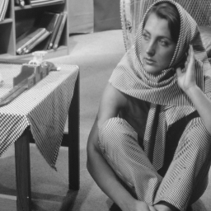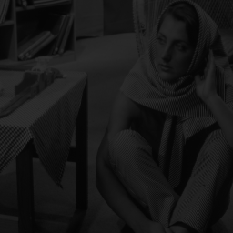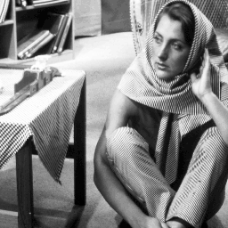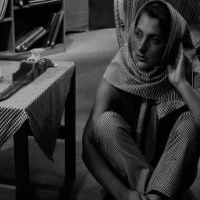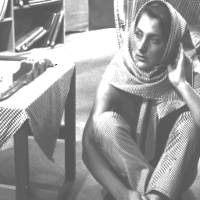

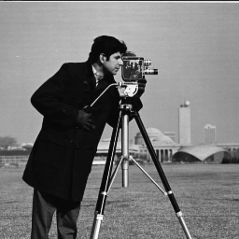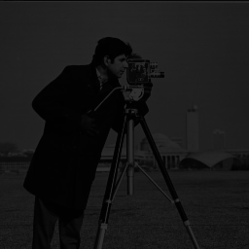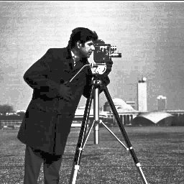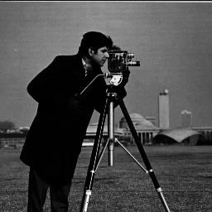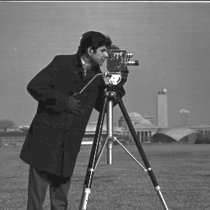

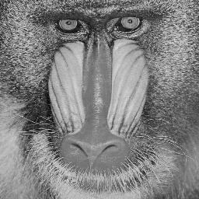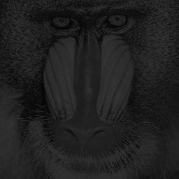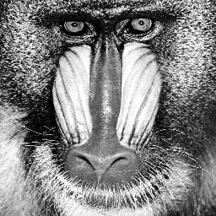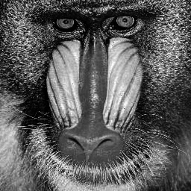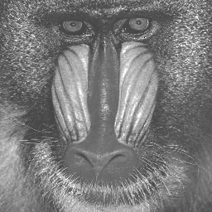

NAME | ORI-INP | ORI-HIS | ORI-PAP | ORI-MOD
1.Balloon | 0.369011  56.8 | 0.3392  57.52 | 0.3201  58.02 | 0.3107  58.28
2.Barbara | 0.4064  55.95 | 0.3446  57.38 | 0.3379  57.55 | 0.3263  57.85
3.Cameraman | 0.4245  55.57 | 0.3846  56.43 | 0.3557  57.11 | 0.3180  58.1
4.Couple | 0.3765  56.62 | 0.3447  57.38 | 0.4818  54.47 | 0.3300  57.76
5.Donalo | 0.2560  59.97 | 0.2660  59.63 | 0.2595  58.72 | 0.2542  60.46
6.Girl | 0.5006  54.57 | 0.5606  53.16 | 0.4761  54.57 | 0.4570  59.28
7.Lena | 0.3228  57.95 | 0.3520  57.20 | 0.2916  58.83 | 0.3107  58.28
8.Mandrill | 0.3804  56.53 | 0.3163  58.13 | 0.2658  59.63 | 0.2335  60.76
9.Pepper | 0.1033  67.85 | 0.5869  52.79 | 0.3898  56.31 | 0.6195  52.29
10.Sania | 0.5188  53.83 | 0.4979  54.196 | 0.4980  54.19 | 0.5372  53.52
11.Zelda | 1.033  47.85 | 0.9172  48.88 | 0.8931  49.13 | 0.8335  48.41

 

